Day3 - Linux Commands:
- Absolute Path
  - An absolute path always starts from / (root) and gives the full location.
  - ls /home/devops/project/logs

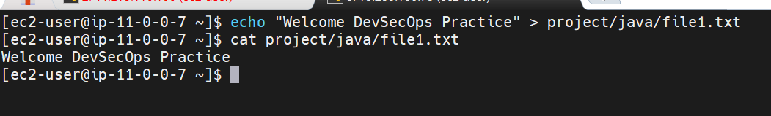
Relative Path:
- A relative path tells Linux where something is based on your current location.
It does not start from /.
- Linux always knows your current working directory. A relative path uses that as the starting point.
- For example:

- To get super user permissions
  - $ sudo su
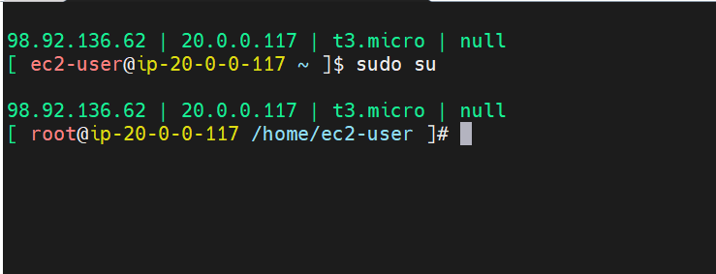
  - $ is normal user
  - # is super user / root
- Uname: to know about system information (kernel information
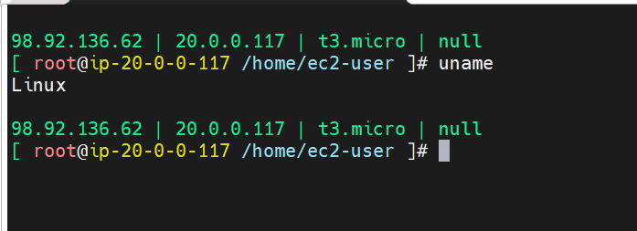

- 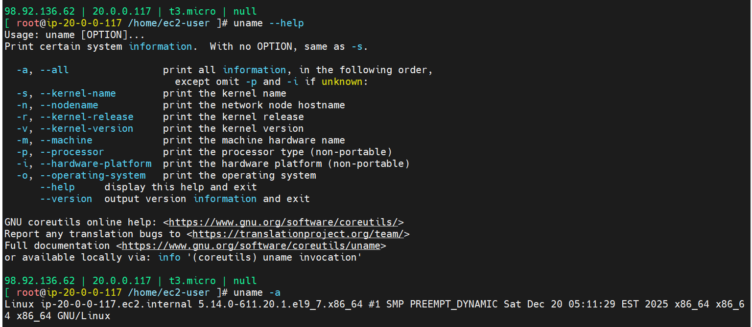
Note: if you want give single letter as OPTIONS then -, if your are giving full name then given --.
- Man : to get full information about the command

- CRUD -> Create Read Update Delete (as a IT engineer you will use these operations in your daily work life).

- $ls – display list of sub-directories and files

  - $ ls -l - Long format
  - $ ls -lr – reverse alphabetical order
  - $ ls -lt - timestamp format
  - $ ls -ltr – latest files at bottom
  - $ ls -ltrhac – human readable format, all
  - $ ls -a – hidden files
  - $ ls -lart – hidden directories and files
- Touch : creating files

  - 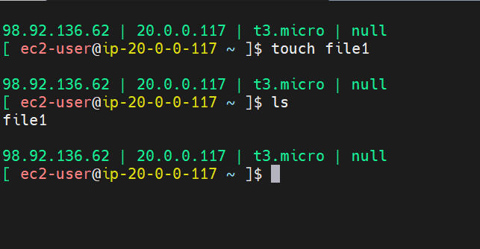
- Mkdir : Make directory
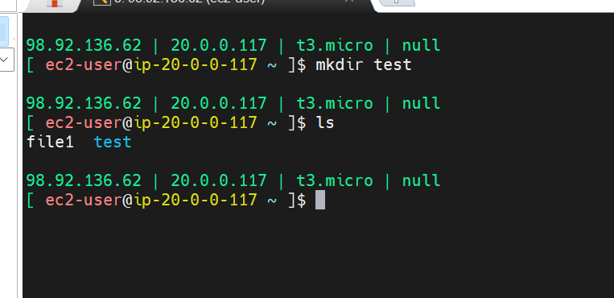

- > -- redirection, usually overrides the previous text
- >> -- appends to the text
- $rm – removes the files
- $rmdir <dir-name> removes directory
- $cd ..
- $ cd

- Copy command:

  - $cp <source> <destination>

- Downloading files and directories
  - Wget and curl
$ wget <link> it is used for downloading packages
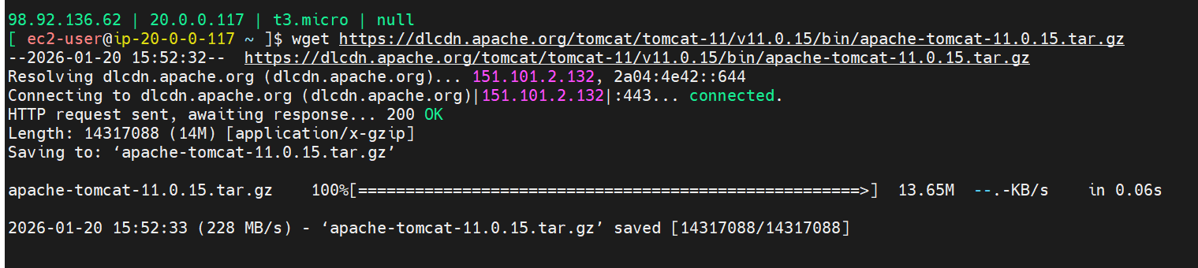
$ curl <link> Shows the o/p on the screen, it will not download by default
Curl is used to hit the API URL’s ( to retrieve the data from other systems)
- $ grep – command to search inside the file
  - $ grep <word to search>
  - -n
  - $grep -c <word> <filename> it counts the no.of fragment
  - $ grep -v <word> <filename> it displays which is not matched
  - $ grep -n <word> filename> display line numbers
  - $ grep -c <word> <filename> matching line numbers count
- Display line number ending with the word architecture
  - $ -> ending character
  - ^ -> starting character
  - Ex: $grep ‘architecture$’ file1.txt
  - Ex: $ grep ‘^ssh’ file1.txt
- Head and tail
  - $ head -n 2 <filename> diaplys top 2 lines
  - $ tail -n 10 <filename> displays bottom 10 lines
  - $ head -n 15 file1 | tail -n 10
  - $ tail -f <file-name> ---- follow the log
- Cut and awk
$ echo https://dlcdn.apache.org/tomcat/tomcat-11/v11.0.15/bin/apache-tomcat-11.0.15.tar.gz | cut -d "/" -f3

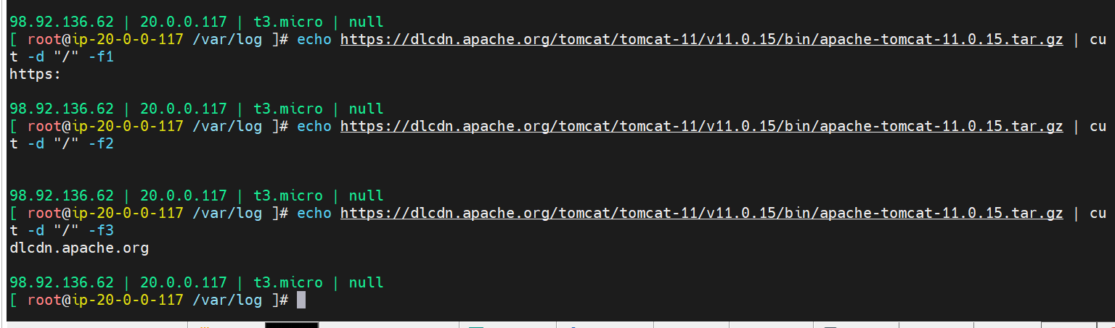
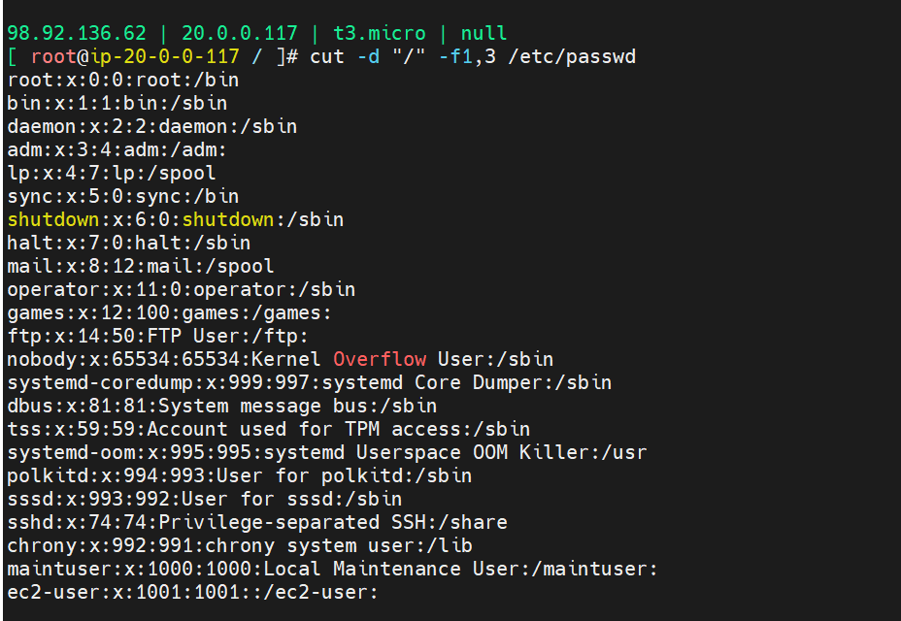
- We can use cut command for displaying the specific sentence in a line using fragmentation (like / , etc)
- $ cut -d “/” -f1 <filename>

- Awk :
  - $ awk -F “/” {print $NF}

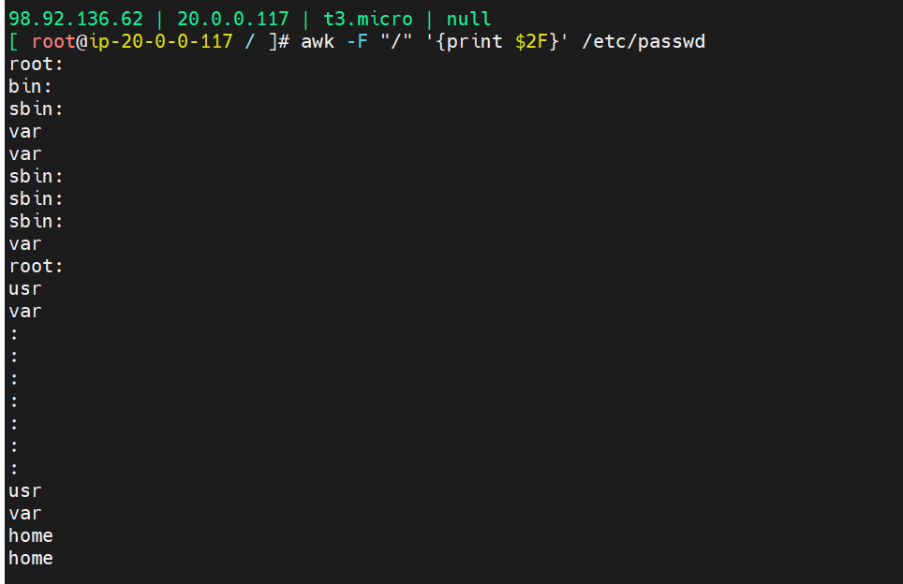

- $ awk -F “:” ‘$3>1000 {print $1F}

